BILKENT UNIVERSITY ENGLISH LANGUAGE PREPARATORY PROGRAM MATERIALS DESCRIPTION FORM

THEME: Unit 6 Health Sciences | TITLE OF THE MATERIAL:U6 Vocabulary Revision

Please tick the course package the material will be used in.
- Q Skills Intro | ¨

SKILL: Vocabulary | OBJECTIVE(S) (Tick and fill in as appropriate) Students will be able to  - Practice Unit 6 Words

Prepared by: ELPP Instructors

HEALTHY LIFE HABITS
A. Under each picture, write the name of the healthy life habit.
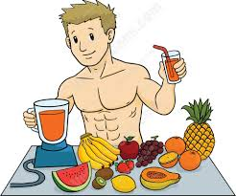
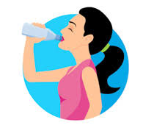
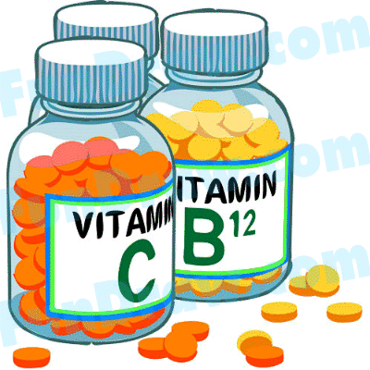
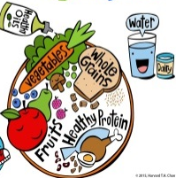
Proper Nutrition
e.g.
eat vegetables and fruit


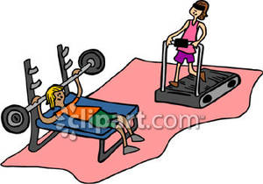

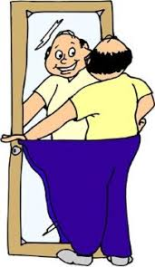

Physical Activity






Rest & Hobb

B. Fill in the blanks using the correct form of the word in the box.
law
- Jane wants to be a ________.
interest
- I am not ________ in running.
feeling
- My brother ________ very happy after doing sports.

- His parents ________ a gym in Antalya.
manager
excited
- Football is a very ________ sport.

C. Complete the gaps with the correct words from the box.
regulary prepare healthy sick

- exercise ______________
- ______________ your own food
- eat ______________
- feel ______________
D. Write sentences with the expressions in Part C.
1. ____________________________________________________________.
2. ____________________________________________________________.
3. ____________________________________________________________.
4. ____________________________________________________________.

